|  |  |
| --- | --- |
| Logo_FPT_University_doc-300x251.jpg | **MINISTRY OF EDUCATION AND TRAINING** |

|  |
| --- |
| **FPT UNIVERSITY** |
| Capstone Project Document |
| [Mobile Travel Guide]  Report No 3: Software Requirement Specification  V1.0 |
|  |
| |  |  | | --- | --- | | **4 – UP** | | | **Group Members** | Nguyễn Thúy Ngân - 00568  Lương Mạnh Hải - 00316  Phùng Việt Dũng - 00515  Thái Hồng Vượng – 00506 | | **Supervisor** | Mr. Nguyễn Tất Trung | | **Ext Supervisor** | Mr. Huỳnh Anh Dũng | | **Capstone Project code** | 0508UP |   **Ha Noi, May 25th, 2011** |
|  |

Table of Contents

[Definitions, Acronyms 3](#_Toc295213605)

[Reference Document List 4](#_Toc295213606)

[Record of change 4](#_Toc295213607)

[3.1 User Requirement Specification 5](#_Toc295213608)

[3.2 System Requirement Specification (Specific requirement) 7](#_Toc295213609)

[3.2.1. External Interface Requirements 7](#_Toc295213610)

[3.2.1.1. User Interfaces 7](#_Toc295213611)

[3.2.1.2. Hardware Interfaces 7](#_Toc295213612)

[3.2.1.3. Software Interfaces 7](#_Toc295213613)

[3.2.1.4. Communications Protocol 7](#_Toc295213614)

[3.2.2. System Features 8](#_Toc295213615)

[3.2.2.1 Server 8](#_Toc295213616)

[3.2.2.1.1 USE CASE – 01 – Language management 8](#_Toc295213617)

[3.2.2.1.2 USE CASE – 02 – Category management 11](#_Toc295213618)

[3.2.2.1.3 USE CASE – 03 – Conversation management 15](#_Toc295213619)

[3.2.2.1.4 USE CASE – 04 – Places management 19](#_Toc295213620)

[3.2.2.2 Client 22](#_Toc295213621)

[3.2.2.2.1 USE CASE – 01 – Select Language 22](#_Toc295213622)

[3.2.2.2.2 USE CASE – 02 – Select conversation category 24](#_Toc295213623)

[3.2.2.2.3 USE CASE – 03 – Conversations details 26](#_Toc295213624)

[3.2.2.2.4 USE CASE – 04 – View map and place 30](#_Toc295213625)

[3.2.2.2.5 USE CASE – 05 – Place details 33](#_Toc295213626)

[3.2.2.2.6 USE CASE – 06 – Group function 36](#_Toc295213627)

[3.2.2.2.7 USE CASE – 07 – User’s Location 40](#_Toc295213628)

[3.2.2.2.8 USE CASE – 08 – set name for user’s device 42](#_Toc295213629)

[3.2.2.2.9 USE CASE – 09 – Currency exchange 43](#_Toc295213630)

[3.2.3. Software System Attributes 44](#_Toc295213631)

[3.2.3.1 Reliability 44](#_Toc295213632)

[3.2.3.2 Availability 44](#_Toc295213633)

[3.2.3.3 Security 45](#_Toc295213634)

[3.2.3.4 Maintainability 45](#_Toc295213635)

[3.2.3.5 Portability 45](#_Toc295213636)

[3.2.3.6 Performance 46](#_Toc295213637)

[3.3 Success Criteria 47](#_Toc295213638)

# Definitions, Acronyms

###### Table 3-a Definitions and Acronyms

|  |  |  |
| --- | --- | --- |
| ID | Acronym | Definition |
| 1 | DB | Database |
| 2 | GUI | Graphical User Interface |
| 3 | GPS | Global Position System |
| 4 | HTTP | Hyper Text Transfer Protocol |
| 5 | GPRS | General Packet Radio Service |
| 6 | REST | Representational State Transfer[[1]](#footnote-1) |
| 7 | A-GPS | Assisted - GPS[[2]](#footnote-2) |
|  |  |  |
|  |  |  |
|  |  |  |

# Reference Document List

###### Table 3-b References Documents list

|  |  |  |  |
| --- | --- | --- | --- |
| No | Title | Version | Description |
| 01 | 0508UP-Travel Guide-Report1 | 1.0 | Introduction of “Mobile Travel Guide” project |
|  |  |  |  |
|  |  |  |  |
|  |  |  |  |
|  |  |  |  |
|  |  |  |  |
|  |  |  |  |
|  |  |  |  |

# Record of change

###### Table 3-c Record of changes

|  |  |  |  |  |
| --- | --- | --- | --- | --- |
| **Effective Date** | **Change Item** | **A/M/D[[[3]](#footnote-3)]** | **Change Description** | **New version** |
| 07/06/2011 | All | A | First Create | 1.0 |
|  |  |  |  |  |
|  |  |  |  |  |
|  |  |  |  |  |
|  |  |  |  |  |

# 3.1 User Requirement Specification

Table 3-1 User Requirement Specification

|  |  |  |
| --- | --- | --- |
| **Type** | **Code** | **Content** |
| **Server management Requirement** | 0508UP\_SMR\_UR01 | Management all the content which updates and store on server. Administrator can add, delete, edit, and list all items… |
| 0508UP\_SMR\_UR02 | Configuration system setting such as the limitation of image, the maximum length of content, the number of image in each place |
| 0508UP\_SMR\_UR03 | Allow manage group of travelers, and application users |
| 0508UP\_SMR\_UR04 | Management application interface is friendly and easy to use |
|  |  |
| **Client user requirement** | 0508UP\_CUR\_UR01 | View and select native and travel language from provided list |
|  | 0508UP\_CUR\_UR02 | View conversation by text with 2 languages; listen to the audio of each sentence of conversations. |
|  | 0508UP\_CUR\_UR03 | Search existed conversation by string that was contained in specific existed conversations. |
|  | 0508UP\_CUR\_UR04 | Add new conversation into local data storage |
|  | 0508UP\_CUR\_UR05 | Update or delete user’s inputted conversations. |
|  | 0508UP\_CUR\_UR06 | Allow user update data of conversations when server have new data |
|  | 0508UP\_CUR\_UR07 | Easy to select concurrency type to exchange between each other. |
|  | 0508UP\_CUR\_UR08 | Exchange currency by the up-to-date rate of travel bank country. |
|  | 0508UP\_CUR\_UR09 | Allow select country to view travel information of it |
|  | 0508UP\_CUR\_UR10 | Allow select method to view information by list or map |
|  | 0508UP\_CUR\_UR11 | Displayed information based on selection of user. There are multi choice for user to view information such as:   * View by distance from user’s location * View all hotels * View all restaurants * View all hospitals * View all attractions * View all famous attractions by categories * View transport station by selection (bus, airport, etc) |
|  | 0508UP\_CUR\_UR12 | With each place, user can view details, description, etc and rank for it. Each user can rank for only one place. |
|  | 0508UP\_CUR\_UR13 | Every user of application will have an account. He can marks favorite place and view list of favourites. |
|  | 0508UP\_CUR\_UR14 | Allow user create, join and sign-out a group.  The group contains all members who travelling together. |
|  | 0508UP\_CUR\_UR15 | Member of a group can   * view other’s position on the map * chat with a member or all group |
|  |  |  |
|  |  |  |

# 3.2 System Requirement Specification (Specific requirement)

## 3.2.1. External Interface Requirements

### 3.2.1.1. User Interfaces

A graphical user interface will be available in all workflow scenarios to allow easy access to all features of the system. The navigation options in every screen will be similar in order to help user can reduce the time learning and using system. All error occurring and exception handling will be catch and display for user with friendly messages.

### 3.2.1.2. Hardware Interfaces

The prototype software will be implemented on mobile phones without additional hardware components:

* Touched screen.
* Internet connection
* GPS: A-GPS
* GPRS: Class 10 (4+1/3+2 slots), 32 - 48 kbps
* Wifi: wi-fi 802.11 b/g/n[[4]](#footnote-4)

We select Sony Ericsson XPERIA X10as device which will be used for the first release of the system.

### 3.2.1.3. Software Interfaces

* Mobile device: Android 2.1 or later.
* Computer: Windows XP or later with C#.Net framework 4.0.

### 3.2.1.4. Communications Protocol

The system uses HTTP1.0 (or over) connection to communicate with server through REST. When the application is launched, it will prompt user for using network signal to connect to the Internet to check with server if there is new data which will be downloaded to display in client. For some other information services such as currency client will request data from the targeted server to update the most recent information then display each time when users choice to see the services.

## 3.2.2. System Features

### 3.2.2.1 Server

#### 3.2.2.1.1 USE CASE – 01 – Language management

This page show “language management” part

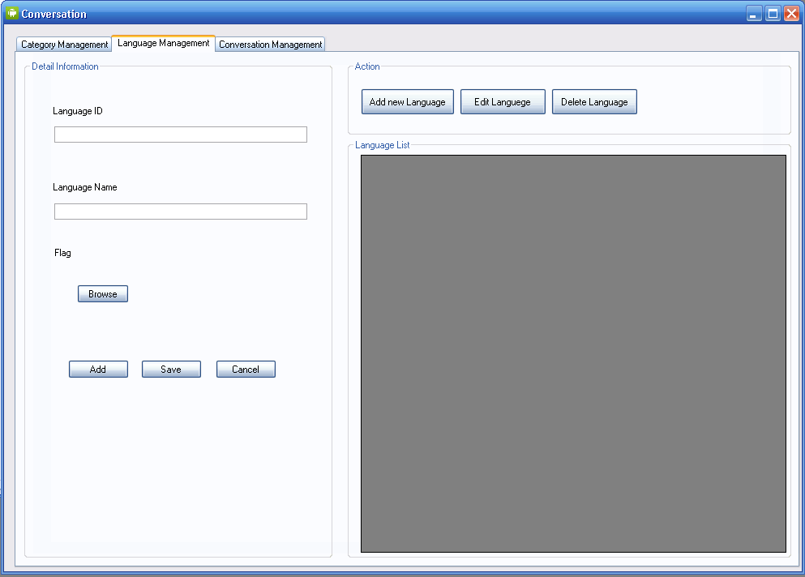

Figure 3.1.1 Language management

Table 3.1.1 Use case – 01 – Language management

|  |  |  |  |
| --- | --- | --- | --- |
| **USE CASE Diagram – 01 – Language management** | | | |
| Figure 3.1.2 Use case 01 | | | |
| **USE CASE – 01 Specification** | | | |
| **Use-case No** | UC01 | **Use-case Version** | 1.0 |
| **Use-case Name** | List All Language | | |
| **Author** | NganNT | | |
| **Date** | 24-05-2011 | **Priority** | Normal |
| **Description**  This use case allow admin view information of all languages which were stored on the system included these below fields   1. LanguageID 2. LanguageName 3. LanguageDescription | | | |
| **Inputs**  N/A | | | |
| **Source**  Language management link, mouse click. | | | |
| **Outputs**  Screen with list of languages in DB | | | |
| **Destination**  Language screen management. | | | |
| **Action**  Click on Language management link at management main menu. | | | |
| **Requires**  System management screen is displayed; “Conversations” management function is available. | | | |
| **Pre-condition**  User login by Administrator role. | | | |
| **Post-condition**  List all language from DB. | | | |
| **Side-effects**  N/A. | | | |
| **Use-case No** | UC02 | **Use-case Version** | 1.0 |
| **Use-case Name** | Add new language | | |
| **Author** | NganNT | | |
| **Date** | 24-05-2011 | **Priority** | Normal |
| **Description**  This use case describe actions to add new language to DB | | | |
| **Inputs**  Language ID, Language Name, | | | |
| **Source**  Text from textField of “Add language” Screen | | | |
| **Outputs**  Language management screen with view part contain new language. | | | |
| **Destination**  Language management screen. | | | |
| **Action**  Step 1: Click button add on “Language management” Screen  Step 2: Input language name, language description into text field  Step 3: Click button add | | | |
| **Requires**  After step 1, add new language screen is displayed.  New language different from existed language in table Languages. | | | |
| **Pre-condition**  Language management screen is displayed | | | |
| **Post-condition**  Add new language to DB successful | | | |
| **Side-effects**  Language management screen | | | |
| **Use-case No** | UC03 | **Use-case Version** | 1.0 |
| **Use-case Name** | Edit Language | | |
| **Author** | NganNT | | |
| **Date** | 24-05-2011 | **Priority** | Normal |
| **Description**  This use case describes action to edit an existed language | | | |
| **Inputs**  Language need to be edited. | | | |
| **Source**  Action of Edit button | | | |
| **Outputs**  Language management screen with view part contain edited language. | | | |
| **Destination**  Language management Screen. | | | |
| **Action**  Step 1: Click on edit link of language which will be edited  Step 2: Edit displayed fields  Step 3: Click on update button | | | |
| **Requires**  After step 1, Edit language screen is displayed | | | |
| **Pre-condition**  Language management screen is displayed | | | |
| **Post-condition**  Information of language is updated to DB | | | |
| **Side-effects**  Language management screen | | | |
| **Use-case No** | UC04 | **Use-case Version** | 1.0 |
| **Use-case Name** | Delete Language | | |
| **Author** | NganNT | | |
| **Date** | 24-05-2011 | **Priority** | Normal |
| **Description**  This use case describes action to Delete an existed language. | | | |
| **Inputs**  Language need to be deleted. | | | |
| **Source**  Action of Delete button | | | |
| **Outputs**  Language management screen with view part not contain deleted language. | | | |
| **Destination**  Language management Screen | | | |
| **Action**  Step 1: Click on Delete link of language which will be deleted  Step 2: Click “OK” on confirm message box | | | |
| **Requires**  After step 1, Confirm message box is displayed. | | | |
| **Pre-condition**  Language management screen is displayed, | | | |
| **Post-condition**  Selected language is removed from DB | | | |
| **Side-effects**  Language management Screen | | | |

#### 3.2.2.1.2 USE CASE – 02 – Category management

This page show “Category management” part

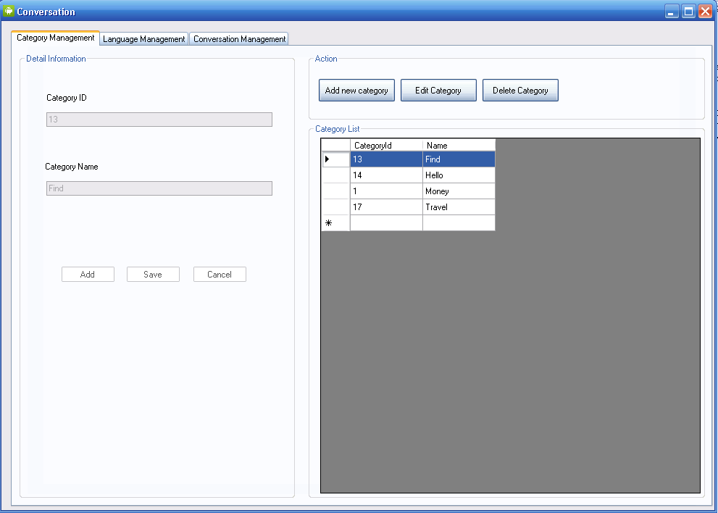

Figure 3.1.3 Category management

Table 3.1.2 Use case – 02 – Category management

|  |  |  |  |
| --- | --- | --- | --- |
| **USE CASE Diagram – 02 – Category management** | | | |
| Figure 3.1.4 Use case 02 | | | |
| **USE CASE Specification** | | | |
| **Use-case No** | UC05 | **Use-case Version** | 1.0 |
| **Use-case Name** | List All Category | | |
| **Author** | NganNT | | |
| **Date** | 24-05-2011 | **Priority** | Normal |
| **Description**  This use case allow admin view information of all Categories which were stored on the system included these below fields   1. CategoryID 2. CategoryName 3. CategoryDescription | | | |
| **Inputs**  N/A | | | |
| **Source**  Category management link, mouse click. | | | |
| **Outputs**  N/A | | | |
| **Destination**  Category screen management. | | | |
| **Action**  Click on Category management link at “Conversations” tab of main menu | | | |
| **Requires**  System management screen is displayed; “Conversations” tab is shown. | | | |
| **Pre-condition**  User login by Administrator role | | | |
| **Post-condition**  List all Categories from table Categories of DB. | | | |
| **Side-effects**  N/A. | | | |
| **Use-case No** | UC06 | **Use-case Version** | 1.0 |
| **Use-case Name** | Add new Category | | |
| **Author** | NganNT | | |
| **Date** | 24-05-2011 | **Priority** | Normal |
| **Description**  This use case describes actions to add new Category to DB. | | | |
| **Inputs**  Category Name, Category Description | | | |
| **Source**  Text from textField of “Add Category” Screen. | | | |
| **Outputs**  N/A | | | |
| **Destination**  N/A | | | |
| **Action**  Step 1: Click button add on “Category management” Screen  Step 2: Input Category name, Category description into text field  Step 3: Click button add | | | |
| **Requires**  After step 1, add new Category screen is displayed.  New Category different from existed Category in table Categories | | | |
| **Pre-condition**  Category management screen is displayed, | | | |
| **Post-condition**  Add new Category to DB successful | | | |
| **Side-effects**  N/A. | | | |
| **Use-case No** | UC07 | **Use-case Version** | 1.0 |
| **Use-case Name** | Edit Category | | |
| **Author** | NganNT | | |
| **Date** | 24-05-2011 | **Priority** | Normal |
| **Description**  This use case describes action to edit an existed Category.. | | | |
| **Inputs**  N/A | | | |
| **Source**  Action of Edit link. | | | |
| **Outputs**  N/A | | | |
| **Destination**  Category management Screen | | | |
| **Action**  Step 1: Click on edit link of Category which will be edited  Step 2: Edit displayed fields  Step 3: Click on update button | | | |
| **Requires**  After step 1, Edit Category screen is displayed | | | |
| **Pre-condition**  Category management screen is displayed, | | | |
| **Post-condition**  Information of Category is updated to DB | | | |
| **Side-effects**  N/A. | | | |
| **Use-case No** | UC08 | **Use-case Version** | 1.0 |
| **Use-case Name** | Delete Category | | |
| **Author** | NganNT | | |
| **Date** | 24-05-2011 | **Priority** | Normal |
| **Description**  This use case describes action to Delete an existed Category. | | | |
| **Inputs**  N/A | | | |
| **Source**  Action of Delete link. | | | |
| **Outputs**  N/A | | | |
| **Destination**  Category management Screen | | | |
| **Action**  Step 1: Click on Delete link of Category which will be deleted  Step 2: Click “OK” on confirm message box | | | |
| **Requires**  After step 1, Confirm message box is displayed. | | | |
| **Pre-condition**  Category management screen is displayed, | | | |
| **Post-condition**  Selected Category is removed from DB | | | |
| **Side-effects**  N/A. | | | |

#### 3.2.2.1.3 USE CASE – 03 – Conversation management

This page show “Conversation management” part

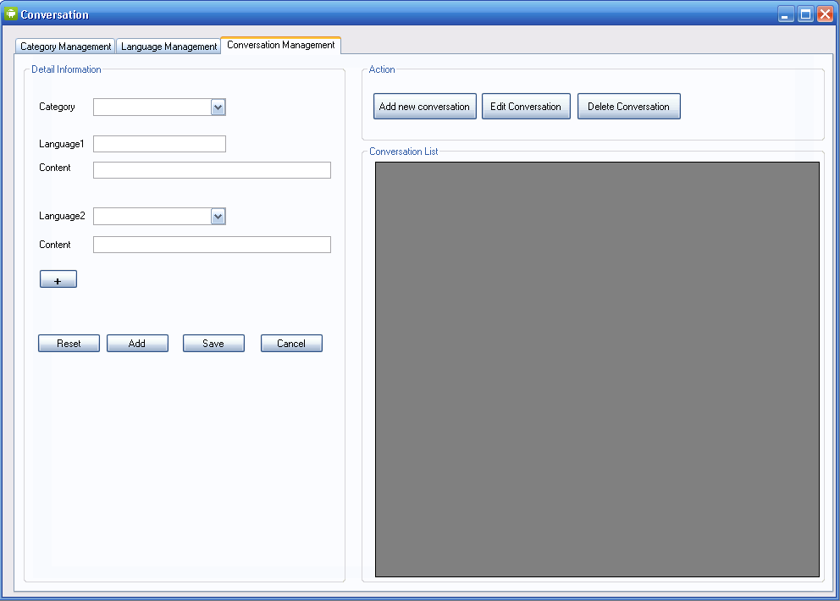Figure 3.1.5 Conversation management

Table 3.1.3 Use case – 03 – Conversation management

|  |  |  |  |
| --- | --- | --- | --- |
| **USE CASE Diagram – 03 – Conversation management** | | | |
| Figure 3.1.6 Use case 03 | | | |
| **USE CASE – Specification** | | | |
| **Use-case No** | UC09 | **Use-case Version** | 1.0 |
| **Use-case Name** | List All Conversation | | |
| **Author** | NganNT | | |
| **Date** | 24-05-2011 | **Priority** | Normal |
| **Description**  This use case allow admin view information of all Conversations which were stored on the system included these below fields   1. ConvID 2. LanguageID 3. Content 4. CategoryID 5. MatchID | | | |
| **Inputs**  N/A | | | |
| **Source**  Conversations management link, mouse click. | | | |
| **Outputs**  N/A | | | |
| **Destination**  Conversation screen management | | | |
| **Action**  Click on Conversation management link at “Conversations” tab of main menu. | | | |
| **Requires**  System management screen is displayed; “Conversations” tab is shown. | | | |
| **Pre-condition**  User login by Administrator role, | | | |
| **Post-condition**  List all Conversation from table Conversations of DB | | | |
| **Side-effects**  N/A. | | | |
| **Use-case No** | UC10 | **Use-case Version** | 1.0 |
| **Use-case Name** | Add new Conversation | | |
| **Author** | NganNT | | |
| **Date** | 24-05-2011 | **Priority** | Normal |
| **Description**  This use case describes actions to add new Conversation to DB. | | | |
| **Inputs**  Conversation Category, Language, content | | | |
| **Source**  Text from textField of “Add Conversation” Screen | | | |
| **Outputs**  N/A | | | |
| **Destination**  N/A | | | |
| **Action**  Step 1: Click button add on “Conversation management” Screen  Step 2: Input Conversation name, Conversation description into text field  Step 3: Click button add | | | |
| **Requires**  After step 1, add new Conversation screen is displayed.  New Conversation different from existed Conversation in table Conversations | | | |
| **Pre-condition**  Conversation management screen is displayed, | | | |
| **Post-condition**  Add new Conversation to DB successful | | | |
| **Side-effects**  N/A. | | | |
| **Use-case No** | UC11 | **Use-case Version** | 1.0 |
| **Use-case Name** | Edit Conversation | | |
| **Author** | NganNT | | |
| **Date** | 24-05-2011 | **Priority** | Normal |
| **Description**  This use case describes action to edit an existed Conversation.. | | | |
| **Inputs**  N/A | | | |
| **Source**  Action of Edit link | | | |
| **Outputs**  N/A | | | |
| **Destination**  Conversation management Screen | | | |
| **Action**  Step 1: Click on edit link of Conversation which will be edited  Step 2: Select new language, Edit content  Step 3: Click on update button | | | |
| **Requires**  After step 1, Edit Conversation screen is displayed. | | | |
| **Pre-condition**  Conversation management screen is displayed | | | |
| **Post-condition**  Information of Conversation is updated to DB | | | |
| **Side-effects**  N/A. | | | |
| **Use-case No** | UC12 | **Use-case Version** | 1.0 |
| **Use-case Name** | Delete Conversation | | |
| **Author** | NganNT | | |
| **Date** | 24-05-2011 | **Priority** | Normal |
| **Description**  This use case describes action to Delete an existed Conversation. | | | |
| **Inputs**  N/A | | | |
| **Source**  Action of Delete link | | | |
| **Outputs**  N/A | | | |
| **Destination**  Conversation management Screen | | | |
| **Action**  Step 1: Click on Delete link of Conversation which will be deleted  Step 2: Click “OK” on confirm message box | | | |
| **Requires**  After step 1, Confirm message box is displayed | | | |
| **Pre-condition**  Conversation management screen is displayed, | | | |
| **Post-condition**  Selected Conversation is removed from DB | | | |
| **Side-effects**  N/A. | | | |

#### 3.2.2.1.4 USE CASE – 04 – Places management

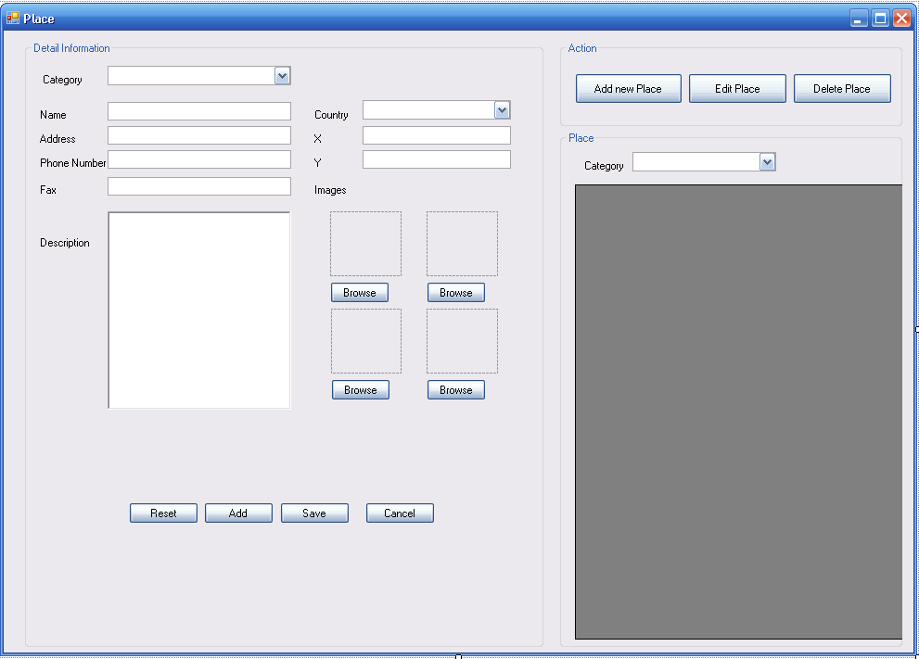

Figure 3.1.7 Place Management

Table 3.1.4 Use case – 04 – Places management

|  |  |  |  |
| --- | --- | --- | --- |
| **USE CASE Diagram** | | | |
| Figure 3.1.8 Use case 04 | | | |
| **USE CASE Specification** | | | |
| **Use-case No** | UC17 | **Use-case Version** | 1.0 |
| **Use-case Name** | List All Place | | |
| **Author** | VuongTH | | |
| **Date** | 24-05-2011 | **Priority** | Normal |
| **Description**  This use case allows admin view information of all places or as category which were stored on the system. Each place will include these below fields   1. PlaceID 2. Name 3. Description 4. Address 5. Rate 6. Country 7. Image link | | | |
| **Inputs**  N/A | | | |
| **Source**  Place management link, mouse click. | | | |
| **Outputs**  N/A | | | |
| **Destination**  Place screen management. | | | |
| **Action**  Click on Place management link at “Conversations” tab of main menu. | | | |
| **Requires**  System management screen is displayed; “Conversations” tab is shown | | | |
| **Pre-condition**  User login by Administrator role. | | | |
| **Post-condition**  List all Place from table Places of DB. | | | |
| **Side-effects**  N/A. | | | |
| **Use-case No** | UC18 | **Use-case Version** | 1.0 |
| **Use-case Name** | Add new Place | | |
| **Author** | VuongTH | | |
| **Date** | 24-05-2011 | **Priority** | Normal |
| **Description**  This use case describe actions to add new Place to DB | | | |
| **Inputs**  Name, Description, Address, image link, Country | | | |
| **Source**  Value from textField and combo-box of “Add Place” Screen | | | |
| **Outputs**  N/A | | | |
| **Destination**  N/A | | | |
| **Action**  Step 1: Click button add on “Place management” Screen  Step 2: Input Place Name, Description, Address, image link into text field, select country  Step 3: Click button add | | | |
| **Requires**  After step 1, add new screen is displayed.  New Place different from existed Place in table Places. | | | |
| **Pre-condition**  Place management screen is displayed | | | |
| **Post-condition**  Add new Place to DB successful | | | |
| **Side-effects**  N/A | | | |
| **Use-case No** | UC19 | **Use-case Version** | 1.0 |
| **Use-case Name** | Edit Place | | |
| **Author** | VuongTH | | |
| **Date** | 24-05-2011 | **Priority** | Normal |
| **Description**  This use case describes action to edit an existed Place | | | |
| **Inputs**  N/A | | | |
| **Source**  Action of Edit link | | | |
| **Outputs**  N/A | | | |
| **Destination**  Place management Screen | | | |
| **Action**  Step 1: Click on edit link of Place which will be edited  Step 2: Edit displayed fields  Step 3: Click on update button | | | |
| **Requires**  After step 1, Edit Place screen is displayed | | | |
| **Pre-condition**  Place management screen is displayed | | | |
| **Post-condition**  Information of Place is updated to DB | | | |
| **Side-effects**  N/A | | | |
| **Use-case No** | UC20 | **Use-case Version** | 1.0 |
| **Use-case Name** | Delete Place | | |
| **Author** | VuongTH | | |
| **Date** | 24-05-2011 | **Priority** | Normal |
| **Description**  This use case describes action to Delete an existed Place. | | | |
| **Inputs**  N/A | | | |
| **Source**  Action of Delete link | | | |
| **Outputs**  N/A | | | |
| **Destination**  Place management Screen | | | |
| **Action**  Step 1: Click on Delete link of Place which will be deleted  Step 2: Click “OK” on confirm message box | | | |
| **Requires**  After step 1, Confirm message box is displayed. | | | |
| **Pre-condition**  Place management screen is displayed, | | | |
| **Post-condition**  Selected Place is removed from DB | | | |
| **Side-effects**  N/A | | | |

### 3.2.2.2 Client

#### 3.2.2.2.1 USE CASE – 01 – Select Language

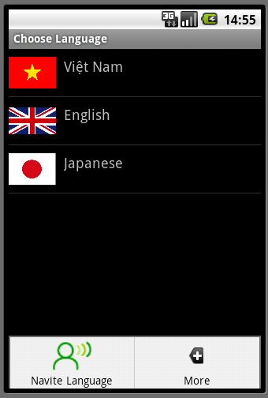

Figure 3.2.1 Select Language

Table 3.2.1 Use case – 01 – Select language

|  |  |  |  |
| --- | --- | --- | --- |
| **USE CASE Diagram** | | | |
| Figure 3.2.2 Use case 01 | | | |
| **USE CASE Specification** | | | |
| **Use-case No** | UC01 | **Use-case Version** | 1.0 |
| **Use-case Name** | Select native language | | |
| **Author** | NganNT | | |
| **Date** | 26-05-2011 | **Priority** | High |
| **Description**  This use case allows user select native language in order to use common conversation part. | | | |
| **Inputs**  Traveler’s native language. | | | |
| **Source**  Action of selecting “Native Language” from menu. | | | |
| **Outputs**  Traveler’s native language | | | |
| **Destination**  Travel language selection screen | | | |
| **Action**  Step1: Select menu  Step 2: Select native language function  Step 3: Select a language from options | | | |
| **Requires**  Application display language for user select. | | | |
| **Pre-condition**  List of language is shown | | | |
| **Post-condition**  Traveler’s native language is set, Travel language selection screen is displayed. | | | |
| **Side-effects**  Category selection. | | | |
| **Use-case No** | UC02 | **Use-case Version** | 1.0 |
| **Use-case Name** | Select travel language | | |
| **Author** | NganNT | | |
| **Date** | 26-05-2011 | **Priority** | Normal |
| **Description**  This use case allows user view select travel language in order to use common conversation part. | | | |
| **Inputs**  Traveler language. | | | |
| **Source**  Action of selecting language from displayed screen. | | | |
| **Outputs**  Language to traveler. | | | |
| **Destination**  Category selection screen | | | |
| **Action**  Select language to travel | | | |
| **Requires**  Application display language for user select. | | | |
| **Pre-condition**  List of language is shown | | | |
| **Post-condition**  Traveler’s native language is set, Category selection screen is displayed. | | | |
| **Side-effects**  Category selection. | | | |

#### 3.2.2.2.2 USE CASE – 02 – Select conversation category

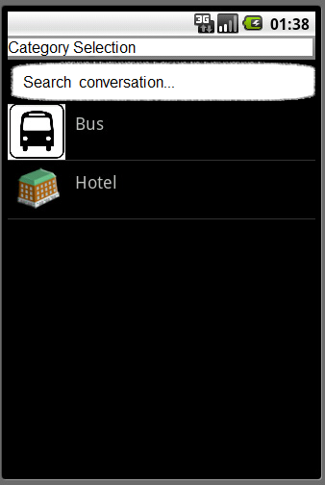

Figure 3.2.3 Select Language

Table 3.2.2 Use case – 02 – Select Language Category

|  |  |  |  |
| --- | --- | --- | --- |
| **USE CASE Diagram** | | | |
| Figure 3.2.4 Use case 02 | | | |
| **USE CASE Specification** | | | |
| **Use-case No** | UC03 | **Use-case Version** | 1.0 |
| **Use-case Name** | Select Language Category | | |
| **Author** | NganNT | | |
| **Date** | 26-05-2011 | **Priority** | High |
| **Description**  This use case allows user select Category in order to use common conversation part. | | | |
| **Inputs**  Category that want to search content of conversation. | | | |
| **Source**  Action of selecting category from screen. | | | |
| **Outputs**  Conversation of selected category | | | |
| **Destination**  Conversation details Screen | | | |
| **Action**  Select category from displayed list. | | | |
| **Requires**  Application display category for user select. | | | |
| **Pre-condition**  List of category is shown | | | |
| **Post-condition**  Conversations details of selected category are listed. | | | |
| **Side-effects**  Conversation details screen. | | | |
| **Use-case No** | UC04 | **Use-case Version** | 1.0 |
| **Use-case Name** | Search conversation | | |
| **Author** | NganNT | | |
| **Date** | 26-05-2011 | **Priority** | Normal |
| **Description**  This use case allows user search conversation with certain string. | | | |
| **Inputs**  A string of a conversation content that want to search | | | |
| **Source**  Value of search text box. | | | |
| **Outputs**  Conversations match search string. | | | |
| **Destination**  Search result screen. | | | |
| **Action**  Step 1: input string need to search into search text box  Step 2: click search | | | |
| **Requires**  N/A | | | |
| **Pre-condition**  User is on Category selection screen. | | | |
| **Post-condition**  A screen displayed search results that match with inputted string. | | | |
| **Side-effects**  N/A | | | |

#### 3.2.2.2.3 USE CASE – 03 – Conversations details

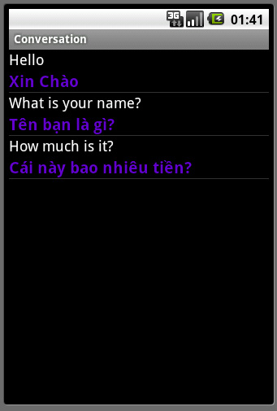

Figure 3.2.5 Conversation details

Table 3.2.3 Use case – 03 – Conversations Details

|  |  |  |  |
| --- | --- | --- | --- |
| **USE CASE Diagram** | | | |
| Figure 3.2.6 Use case 03 | | | |
| **USE CASE Specification** | | | |
| **Use-case No** | UC05 | **Use-case Version** | 1.0 |
| **Use-case Name** | View and listen Conversations | | |
| **Author** | NganNT | | |
| **Date** | 26-05-2011 | **Priority** | High |
| **Description**  This use case allows user view common conversations with text and audio | | | |
| **Inputs**  N/A | | | |
| **Source**  N/A | | | |
| **Outputs**  Common conversations | | | |
| **Destination**  Conversation screen | | | |
| **Action**  Step1: Select native language  Step 2: Select Travel language  Step 3: Select Category of conversations | | | |
| **Requires**  Conversations are stored in user’s device | | | |
| **Pre-condition**  List of language is shown | | | |
| **Post-condition**  Conversations are shown as selected category | | | |
| **Side-effects**  N/A. | | | |
| **Use-case No** | UC06 | **Use-case Version** | 1.0 |
| **Use-case Name** | Search Conversation | | |
| **Author** | NganNT | | |
| **Date** | 26-05-2011 | **Priority** | Normal |
| **Description**  This use case describe requirements of search conversation function | | | |
| **Inputs**  String to search | | | |
| **Source**  Value of search textField on screen | | | |
| **Outputs**  All conversations match search string | | | |
| **Destination**  Conversation list screen | | | |
| **Action**  Step 1: input text on Search text-filed  Step 2: Click search icon | | | |
| **Requires**  N/A | | | |
| **Pre-condition**  Category list screen has search field | | | |
| **Post-condition**  Return result match with search condition | | | |
| **Side-effects**  N/A | | | |
| **Use-case No** | UC07 | **Use-case Version** | 1.0 |
| **Use-case Name** | Add new Conversation | | |
| **Author** | NganNT | | |
| **Date** | 26-05-2011 | **Priority** | Normal |
| **Description**  This use case describe actions to add new Conversation to storage | | | |
| **Inputs**  Conversation Category, Language, content | | | |
| **Source**  Value from textField and combo-box of “Add Conversation” Screen | | | |
| **Outputs**  N/A | | | |
| **Destination**  N/A | | | |
| **Action**  Step 1: Click icon add from menu  Step 2: Input Place Conversation Category, Language, content of at least 2 languages, and one of them is English  Step 3: Click button add | | | |
| **Requires**  After step 1, add new screen is displayed. | | | |
| **Pre-condition**  Category list screen is displayed | | | |
| **Post-condition**  Add new Conversation to Storage successful | | | |
| **Side-effects**  N/A | | | |
| **Use-case No** | UC08 | **Use-case Version** | 1.0 |
| **Use-case Name** | Edit Conversation | | |
| **Author** | NganNT | | |
| **Date** | 24-05-2011 | **Priority** | Normal |
| **Description**  This use case describes action to edit an user input conversation | | | |
| **Inputs**  N/A | | | |
| **Source**  Action of Edit icon | | | |
| **Outputs**  N/A | | | |
| **Destination**  Current conversation list | | | |
| **Action**  Step 1: Click on edit icon beside user input conversation  Step 2: Edit displayed fields  Step 3: Click on update button | | | |
| **Requires**  After step 1, Edit conversation screen is displayed | | | |
| **Pre-condition**  User input conversation is display with edit icon | | | |
| **Post-condition**  Conversation of user input is updated in storage | | | |
| **Side-effects**  N/A | | | |
| **Use-case No** | UC09 | **Use-case Version** | 1.0 |
| **Use-case Name** | Delete Conversation | | |
| **Author** | NganNT | | |
| **Date** | 24-05-2011 | **Priority** | Normal |
| **Description**  This use case describes action to Delete a user input conversation. | | | |
| **Inputs**  N/A | | | |
| **Source**  Action of Delete icon | | | |
| **Outputs**  N/A | | | |
| **Destination**  Conversation list | | | |
| **Action**  Step 1: Click on Delete icon beside conversation will be deleted  Step 2: Click “OK” on confirm message | | | |
| **Requires**  After step 1, Confirm message is displayed. | | | |
| **Pre-condition**  User input conversation is displayed, | | | |
| **Post-condition**  Selected conversation is removed from storage | | | |
| **Side-effects**  N/A | | | |

#### 3.2.2.2.4 USE CASE – 04 – View map and place

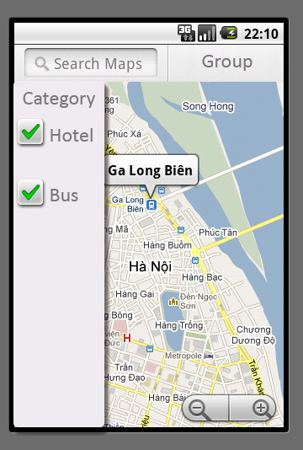

Figure 3.2.7 View place

Table 3.2.4 Use case – 04 – View map and place

|  |  |  |  |
| --- | --- | --- | --- |
| **USE CASE Diagram** | | | |
| Figure 3.2.8 View map and place | | | |
| **USE CASE Specification** | | | |
| **Use-case No** | UC10 | **Use-case Version** | 1.0 |
| **Use-case Name** | Select Place Category | | |
| **Author** | HaiLM | | |
| **Date** | 26-05-2011 | **Priority** | High |
| **Description**  User select different categories from left menu to display on map such as: landscapes, hotels, restaurants, train stations, bus station, and airport. | | | |
| **Inputs**  Selected categories | | | |
| **Source**  Value of check-boxes of category selection | | | |
| **Outputs**  Places of selected category | | | |
| **Destination**  Map with matched places | | | |
| **Action**  Select categories to view on map at left menu | | | |
| **Requires**  Map is displayed | | | |
| **Pre-condition**  Suitable places are available. | | | |
| **Post-condition**  Places that mapped selected categories are display on map. | | | |
| **Side-effects**  Place details. | | | |
| **Use-case No** | UC11 | **Use-case Version** | 1.0 |
| **Use-case Name** | Search | | |
| **Author** | NganNT | | |
| **Date** | 24-05-2011 | **Priority** | Normal |
| **Description**  This use case allows user search place by input string into search box | | | |
| **Inputs**  String that involves place wants to search. | | | |
| **Source**  Value of search box. | | | |
| **Outputs**  All places mapped with search condition are displayed. | | | |
| **Destination**  Map screen | | | |
| **Action**  Step 1: input string to search box  Step 2: Click search | | | |
| **Requires**  Search box is displayed. | | | |
| **Pre-condition**  N/A | | | |
| **Post-condition**  Places mapped with search condition are displayed. | | | |
| **Side-effects**  Place details. | | | |
| **Use-case No** | UC12 | **Use-case Version** | 1.0 |
| **Use-case Name** | Zoom map | | |
| **Author** | NganNT | | |
| **Date** | 24-05-2011 | **Priority** | Normal |
| **Description**  This use case allows user view map with different view level. | | | |
| **Inputs**  View level | | | |
| **Source**  Value of zoom bar. | | | |
| **Outputs**  All places mapped with search condition are displayed. | | | |
| **Destination**  Map screen | | | |
| **Action**  Click on [+] to zoom in, [-] to zoom out. | | | |
| **Requires**  Application provide different view level | | | |
| **Pre-condition**  N/A | | | |
| **Post-condition**  View level of map is changed along with the changes of zoom bar | | | |
| **Side-effects**  Map screen | | | |
| **Use-case No** | UC13 | **Use-case Version** | 1.0 |
| **Use-case Name** | Group | | |
| **Author** | NganNT | | |
| **Date** | 24-05-2011 | **Priority** | Normal |
| **Description**  This use case allows user use group function of application | | | |
| **Inputs**  N/A | | | |
| **Source**  Action of touching Group button | | | |
| **Outputs**  Group screen is displayed | | | |
| **Destination**  Group Screen | | | |
| **Action**  Click Group button | | | |
| **Requires**  Group option is available | | | |
| **Pre-condition**  N/A | | | |
| **Post-condition**  User use group function. | | | |
| **Side-effects**  N/A | | | |

#### 3.2.2.2.5 USE CASE – 05 – Place details

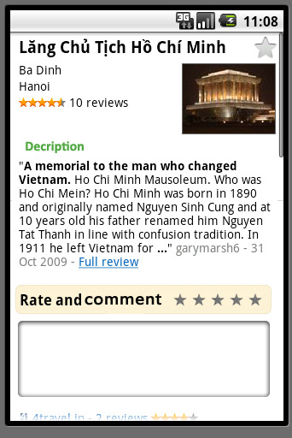

Figure 3.2.9 Place Details

Table 3.2.5 Use case – 05 – Place Details

|  |  |  |  |
| --- | --- | --- | --- |
| **USE CASE Diagram** | | | |
| Figure 3.2.10 Use case 05 | | | |
| **USE CASE Specification** | | | |
| **Use-case No** | UC14 | **Use-case Version** | 1.0 |
| **Use-case Name** | View Place Details | | |
| **Author** | HaiLM | | |
| **Date** | 26-05-2011 | **Priority** | Normal |
| **Description**  This use case allows traveler view details information of certain place such as: address, raking rate, review by users, etc. | | | |
| **Inputs**  Place want to view details. | | | |
| **Source**  Place icon on map. | | | |
| **Outputs**  Details information of a place | | | |
| **Destination**  Places details screen | | | |
| **Action**  Touch icon of a place on map | | | |
| **Requires**  Place has details on server | | | |
| **Pre-condition**  Place has details on server | | | |
| **Post-condition**  Details screen is displayed with details information, ranking and comment function for user. | | | |
| **Side-effects**  Raking | | | |
| **Use-case No** | UC15 | **Use-case Version** | 1.0 |
| **Use-case Name** | Ranking | | |
| **Author** | HaiLM | | |
| **Date** | 26-05-2011 | **Priority** | Normal |
| **Description**  Travelers rate for a place as how much they like it. | | | |
| **Inputs**  Rate want to rank ( from 1 star to 5 stars) | | | |
| **Source**  Ranking stars | | | |
| **Outputs**  Ranked place | | | |
| **Destination**  Detail screen. | | | |
| **Action**  Step 1: Touch the ranking icon in a moment  Step 2: select number of start that response the interest rate | | | |
| **Requires**  “Detail” screen is displayed | | | |
| **Pre-condition**  User haven’t ranked for that place | | | |
| **Post-condition**  Rates point of place are stored on server and the average ranking of place is calculates an update to screen. | | | |
| **Side-effects**  Place details | | | |
| **Use-case No** | UC16 | **Use-case Version** | 1.0 |
| **Use-case Name** | Comment | | |
| **Author** | HaiLM | | |
| **Date** | 26-05-2011 | **Priority** | Normal |
| **Description**  Traveler makes review for a place by using this function | | | |
| **Inputs**  Ranking form one to five stars. Text. | | | |
| **Source**  Ranking bar, Edit text. | | | |
| **Outputs**  Place have been ranking. | | | |
| **Destination**  Detail screen. | | | |
| **Action**  Step 1: Touch the ranking icon in a moment  Step 2: select number of start that response the interest rate  Step 3: give comment to comment text field  Step 4: finish raking and comment | | | |
| **Requires**  “Detail” screen is displayed | | | |
| **Pre-condition**  User haven’t ranked for that place | | | |
| **Post-condition**  Raking and comment of place is stored on server and the average ranking of place is calculates an update to table places. | | | |
| **Side-effects**  N/A | | | |

#### 3.2.2.2.6 USE CASE – 06 – Group function

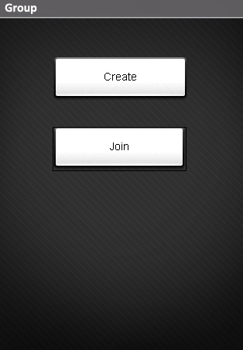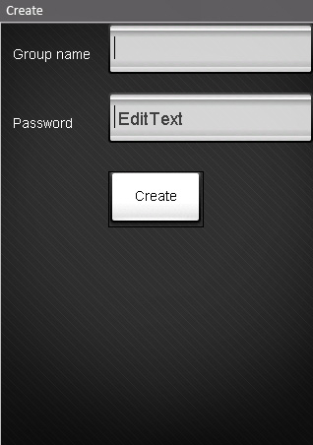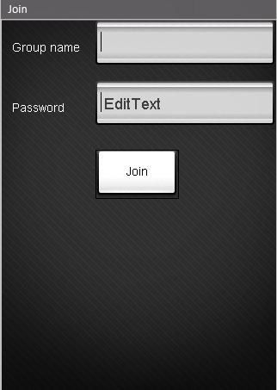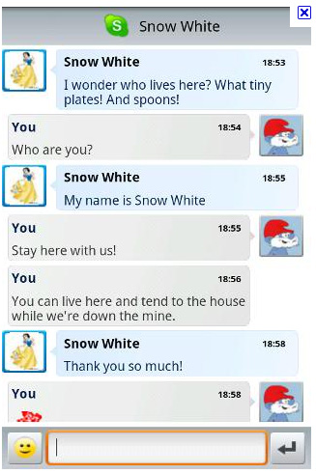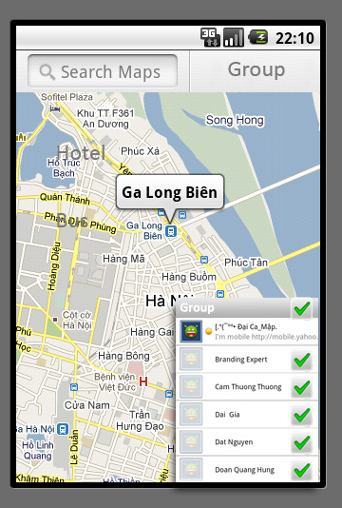

Figure 3.2.11 Group Function

Table 3.2.6 Use case – 06 – Group function

|  |  |  |  |
| --- | --- | --- | --- |
| **USE CASE Diagram** | | | |
| Figure 3.2.12 Use case 06 | | | |
| **USE CASE Specification** | | | |
| **Use-case No** | UC17 | **Use-case Version** | 1.0 |
| **Use-case Name** | Create Group | | |
| **Author** | HaiLM | | |
| **Date** | 26-05-2011 | **Priority** | High |
| **Description**  Application will help user create a group to travel together. In fact, we often travel together like a group. Application provides user several advantages to interact with other. Group creator can share login information of group with his friend. | | | |
| **Inputs**  User input group name and password | | | |
| **Source**  Group name and password from text field. | | | |
| **Outputs**  A group has been creating. | | | |
| **Destination**  Group screen | | | |
| **Action**  Step1: Select group function from menu  Step 2: Select Create Group  Step 3: Input required fields  Step 4: finish creating group | | | |
| **Requires**  User has account | | | |
| **Pre-condition**  N/A | | | |
| **Post-condition**  Group is created, Information is stored in server database | | | |
| **Side-effects**  N/A. | | | |
| **Use-case No** | UC18 | **Use-case Version** | 1.0 |
| **Use-case Name** | Join Group | | |
| **Author** | HaiLM | | |
| **Date** | 26-05-2011 | **Priority** | Normal |
| **Description**  Join a group to travel with your friend. | | | |
| **Inputs**  Group name and password. | | | |
| **Source**  Information of name and password from group’s creator. | | | |
| **Outputs**  User join to group, a status will be show to the user. | | | |
| **Destination**  View map and place’s screen. | | | |
| **Action**  Step 1: Select join group function from menu  Step 2: input group name and password  Step 3: Touch join button | | | |
| **Requires**  User was login. | | | |
| **Pre-condition**  User belongs to a valid group | | | |
| **Post-condition**  User join group successful. | | | |
| **Side-effects**  N/A | | | |
| **Use-case No** | UC19 | **Use-case Version** | 1.0 |
| **Use-case Name** | Out Group | | |
| **Author** | HaiLM | | |
| **Date** | 26-05-2011 | **Priority** | Normal |
| **Description**  This use case allows user get out of a group. | | | |
| **Inputs**  N/A | | | |
| **Source**  Button Out of group | | | |
| **Outputs**  N/A | | | |
| **Destination**  Map screen | | | |
| **Action**  Step 1: select out of group function  Step 2: select “OK” in confirm message | | | |
| **Requires**  N/A | | | |
| **Pre-condition**  User is in a group at that moment. | | | |
| **Post-condition**  User out of group | | | |
| **Side-effects**  N/A | | | |
| **Use-case No** | UC20 | **Use-case Version** | 1.0 |
| **Use-case Name** | Chat | | |
| **Author** | HaiLM | | |
| **Date** | 26-05-2011 | **Priority** | Normal |
| **Description**  When user have join in a group. User can chat to your group by shout box, or chatting with another user, by click on their avatar. | | | |
| **Inputs**  Text on shout box | | | |
| **Source**  User in group. | | | |
| **Outputs**  Message with be display in box chat, and to other user. | | | |
| **Destination**  Group screen. | | | |
| **Action**  Chat group:   * Input message into shout box * Click send   Chat with particular friend   * Select friend from list * Input message * Click send | | | |
| **Requires**  Group has more than one member (include current user) | | | |
| **Pre-condition**  User belongs to a group | | | |
| **Post-condition**  Conversation of user input is updated in storage | | | |
| **Side-effects**  N/A | | | |
| **Use-case No** | UC21 | **Use-case Version** | 1.0 |
| **Use-case Name** | View member position | | |
| **Author** | HaiLM | | |
| **Date** | 26-05-2011 | **Priority** | Normal |
| **Description**  Group will show user a function to share their location to other user in group. With GPS sharing, user can easily find down their friend‘s position. | | | |
| **Inputs**  All group member’s location. | | | |
| **Source**  From GPS. | | | |
| **Outputs**  Screen shows location of member in a group. | | | |
| **Destination**  Map and place screen. | | | |
| **Action**  Select group’s position from menu | | | |
| **Requires**  Group members’ device support GPS | | | |
| **Pre-condition**  User joined group | | | |
| **Post-condition**  Position of all member of group is shown on map | | | |
| **Side-effects**  N/A | | | |

#### 3.2.2.2.7 USE CASE – 07 – User’s Location

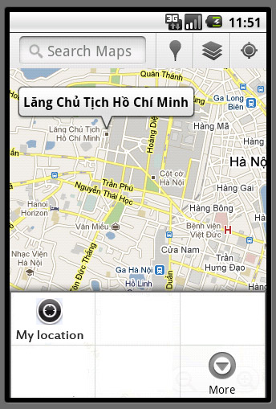

Figure 3.2.13 User’s location

Table 3.2.7 Use case – 07 User’s location

|  |  |  |  |
| --- | --- | --- | --- |
| **USE CASE Diagram** | | | |
| Figure 3.2.14 Use case 07 | | | |
| **USE CASE Specification** | | | |
| **Use-case No** | UC22 | **Use-case Version** | 1.0 |
| **Use-case Name** | User’s Location | | |
| **Author** | HaiLM | | |
| **Date** | 26-05-2011 | **Priority** | Normal |
| **Description**  Show user’s location by GPS | | | |
| **Inputs**  User’s location | | | |
| **Source**  GPS | | | |
| **Outputs**  Location of user | | | |
| **Destination**  Map and place screen | | | |
| **Action**  User select “View my Location” function from menu | | | |
| **Requires**  GPS is available | | | |
| **Pre-condition**  N/A | | | |
| **Post-condition**  Current position of traveler is shown on the map | | | |
| **Side-effects**  N/A | | | |

#### 3.2.2.2.8 USE CASE – 08 – set name for user’s device

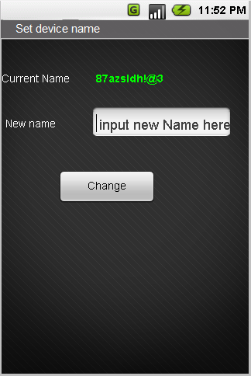

Figure 3.2.15 Set name for device

Table 3.8 Use case – 08 Set name for user’s device

|  |  |  |  |
| --- | --- | --- | --- |
| **USE CASE Diagram** | | | |
| Figure 3.2.16 Use case 06 | | | |
| **USE CASE Specification** | | | |
| **Use-case No** | UC23 | **Use-case Version** | 1.0 |
| **Use-case Name** | Set Name for device | | |
| **Author** | HaiLM | | |
| **Date** | 26-05-2011 | **Priority** | Normal |
| **Description**  Set name for android device in order to make it easy to remember. | | | |
| **Inputs**  Name need to be set | | | |
| **Source**  Text on name edit box. | | | |
| **Outputs**  N/A | | | |
| **Destination**  Show user name in up bar screen. | | | |
| **Action**  Step 1: input new name to edit box.  Step 2: select save | | | |
| **Requires**  N/A | | | |
| **Pre-condition**  N/A | | | |
| **Post-condition**  User’s device name is changed. | | | |
| **Side-effects**  Group function | | | |

#### 3.2.2.2.9 USE CASE – 09 – Currency exchange

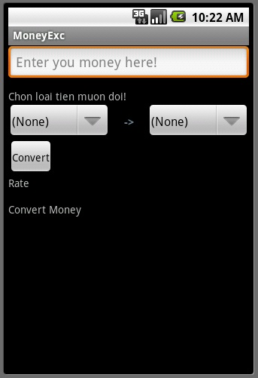

Figure 3.2.17 Currency exchange

Table 3.2.9 Use case – 09 Currency exchange

|  |  |  |  |
| --- | --- | --- | --- |
| **USE CASE Diagram** | | | |
| Figure 3.2.18 Use case 09 | | | |
| **USE CASE Specification** | | | |
| **Use-case No** | UC24 | **Use-case Version** | 1.0 |
| **Use-case Name** | Currency Convert | | |
| **Author** | DungPV | | |
| **Date** | 26-05-2011 | **Priority** | Normal |
| **Description**  When users choose this application, they can currency exchange with exchange rate using up-to-the-minutes rates when they travel some country. | | | |
| **Inputs**  Number and rate to convert | | | |
| **Source**  Number text box, currency rate exchange from a bank website | | | |
| **Outputs**  Show money converted | | | |
| **Destination**  Currency exchange screen | | | |
| **Action**  Step 1: Type number in the edit box.  Step 2: Select native currency.  Step 3: Select currency want to convert  Step 4: Click “Convert” button.  Step 5: Show money converted. | | | |
| **Requires**  N/A | | | |
| **Pre-condition**  N/A | | | |
| **Post-condition**  Result will show money converted. | | | |
| **Side-effects**  N/A | | | |

## 3.2.3. Software System Attributes

### 3.2.3.1 Reliability

* The data which is used for the system is collected from reliable source. The data also be review and checked the duplicate and consistence.
* The information service gets data from service resources in real time, so user always see the newest information.

### 3.2.3.2 Availability

* The server can run 24/7 and support for a large number of user. People can use the system every time and everywhere with their mobile and internet connection (GPRS or Wireless).
* The system also support offline mode for user to storage data on their client to save favorite content or using when they can’t connect to the internet.

### 3.2.3.3 Security

Application which used for manage the data on the server side has authentication and authorization to avoid the unaccepted access.

|  |  |  |
| --- | --- | --- |
| **Function** | **Server Administrator** | **Traveler** |
| Language List |  |  |
| View | X[[5]](#footnote-5) | X |
| Add – Edit – Delete | X | O[[6]](#footnote-6) |
| Language category |  |  |
| View | X | X |
| Add – Edit – Delete | X | O |
| Conversation (system) |  |  |
| View | X | X |
| Add – Edit - Delete | X | O |
| Place Information |  |  |
| Details information |  |  |
| View | X | X |
| Add – Edit – Delete | X | O |
| Rank | O | X |
| Comment | O | X |
| Group |  |  |
| Create | O | X |
| Join | O | X |
| Out | O | X |
| Delete | X | O |
|  |  |  |

### 3.2.3.4 Maintainability

* The software development phase will follow the Project Coding Convention which is designed to help the team create explicit source code.
* Besides, the development will follow the Object-Oriented Paradigm[[[7]](#footnote-7)]. This will lead to easily maintenance and upgrading of the application in the future.

### 3.2.3.5 Portability

* The data structure is designed independent to the programming language, so it can be stored in many kinds of format.
* We build our protocol to do data exchange between client and server, the protocol has simple format and based on common internet technology, so the change of platform does not miss much difficulty.
* The porting of the system requires just porting the source code to new programming language and new platform.

### 3.2.3.6 Performance

The system screens which process and store data on the client can response in 10 second. When the system synchronize or update data which the server, information service, the performance will depend on the network coverage’s condition. The system will be optimize to reduce bandwidths and has the timeout value of 120 seconds.

# 3.3 Success Criteria

|  |  |  |  |
| --- | --- | --- | --- |
| No. | Success Criteria | | Description |
| 1 | Quality of application | - Execute all Use cases | When all use case are execute, we can ensure that all user requirement are done. |
| - Performance | Response time quickly, device requirement in low. (Have define in SRS) |
| - Pass testing stage | Pass testing stage with high percent of successful test case. |
| - Non function requirement | Application must have nice interface. Following standard to make user feel familiar when using. |
| 2 | Time | | Complete project in time, ensure plan meet the deadline. |
| 3 | Human | - Knowledge | Studying android programming, practicing software process from project. |
| - Match of project | All member of team are expected to have good match of project. |

1. Representational State Transfer - <http://en.wikipedia.org/wiki/Representational_State_Transfer> [↑](#footnote-ref-1)
2. Assisted – GPS - <http://en.wikipedia.org/wiki/A-GPS> [↑](#footnote-ref-2)
3. A - Added M - Modified D\* – Deleted [↑](#footnote-ref-3)
4. IEEE 802.11 http://en.wikipedia.org/wiki/IEEE\_802.11 [↑](#footnote-ref-4)
5. X: has right [↑](#footnote-ref-5)
6. O: has NO right [↑](#footnote-ref-6)
7. Object-Oriented programing <http://en.wikipedia.org/wiki/Object-oriented_programming> [↑](#footnote-ref-7)